

**University of Pisa**

Laurea Magistrale (MSc) in Artificial Intelligence and Data Engineering

**Project**

Large-Scale and Multi-Structured Databases

**UniMusic**

Academic year 2020-2021

Lorenzo Bianchi, Valerio Giannini, Alessio Serra

**Github**: https://github.com/ValeGian/LSMDB_UniMusic

**Index**

**- Introduction and Requirements**…………….……………………………………………………4

**-** Functional Requirements……………….…………………………………………………..…4

**-** Non Functional Requirements………….……………………………………………………..5

**- Specifications**……………………………….….………………………………………………..…5

**-** Actors and Use Case Diagram………...……..………………………………………………..5

**-** Analysis Class Diagram……………………………………………………………………….6

**- Architectural Design**………………………………………………………………………………7

**-** Software Architecture…………………………………………………………………………7

**-** Client Side………………………………………………………………………………..7

**-** Server Side……………………………………………………………………………….7

**-** Architecture Diagram…………………………………………………………………….8

**-** Dataset Organization and Database Population……………………………………………….9

**-** Selected NoSQL Databases…………………..………………………………………………10

**- MongoDB Design and Implementation**………………………………………………………....11

**-** User Collection……………………………………………………………………………….11

**-** Song Collections……………………………………………………………………………..12

**-** CRUD Operations……………………………………………………………………………12

**-** Create…………………………………………………………………………………...12

**-** Read…………………………………………………………………………………….13

**-** Update………………………………………………………………………………..…16

**-** Delete…………………………………………………………………………………...17

**-** Queries Analysis and MongoDB Connection String………………………………………...18

**-** Analytics and Statistics………………………………………………………………………18

**-** Artists with Most Hit Songs…………………………………………………………….18

**-** Top Rated Album per Decade…………………………………………………………..19

**-** Top Favourite Genres…………………………………………………………………...20

**-** Top Favourite Artist per Age Range……………………………………………………21

**-** Index Analysis………………………………………………………………………………..23

**-** Index “artist”..…………….…………………………………………………………….23

**-** Index “album”…………….…………………………………………………………….24

**-** Index “title”……………….…………………………………………………………….24

**- Neo4j Design and Implementation**……………………………………………………………...26

**-** Nodes………………….……………………………………………………………...……....26

**-** Relations……………….……………………………………………………………...……...26

**-** Queries Implementation.……………………………………………………………………..27

- CRUD operation.………………………………………………………….……………….27

- Create..…………………………………………………………….……………….27

- Read..………………………………………………………………………………27

- Update…..………………………………………………………………………....28

- Delete ……………………………………………………………………………..28

- “On-graph” queries………………………………………………………………………..30

- Suggested User…………………………………………………………………….31

- Suggested Playlist………………………………………………………………….31

- Hot songs ………………………………………………………………………….32

- Neo4j Indexes ……………………………………………………………………………..32

**- Other Implementation Details**…………………………………………………………………..33

**-** Shards Configuration and Non-Functional Requirements…………………………………...33

**-** Cross-Database Consistency Management…………………………………………………..33

**-** Application Package Structure……………………………………………………………….35

**- User Manual**……………………………………………………………………………………...36

**-** Login and Registration……………………………………………………………………….36

**-** Home page…………………………………………………………………………………...37

**-** Song page………………..…………………………………………………………………...39

**-** User page………………..…………………………………………………………………...39

**-** Playlist page……………..…………………………………………………………………...40

**-** Admin………………………………………………………………………………………...41

**Introduction and Requirements**

***UniMusic*** is an application whose main intent is to provide *songs discovery and managing service*; songs that can be found on the platform are associated with links to official sources on the internet where users can listen to them (e.g., *official YouTube/Spotify source*).

The application provides general information about each song it stores (e.g., its name, genre, artist) and offers to users the possibility to search and browse for them, possibly applying specific filters to reduce the searching scope. Users are then allowed to express their thoughts on songs through a “*like*” system and eventually add them to their *favourites*.

In order to simplify and enhance users’ experience, they can organize songs in *playlists* they create or *follow* other people’s playlists. They are also allowed to *follow* other users in order to get *suggestions* about songs and playlists they may like.

**Functional Requirements**

**Anonymous Users:**

* Anonymous Users can **register** a Standard User account on the platform.
* Anonymous Users can **log in**as Standard User or as Admin.

**Standard Users:**

* *Standard Users*can **search** for *Songs*:
  + by title.
  + by artist.
  + by album.
* *Standard Users* can **manage** *Playlists*:
  + *Standard Users*can **create** a new playlist.
  + *Standard Users* can **add** and **remove** songs to their playlists.
  + *Standard Users* can **update** the name to their playlists.
  + *Standard Users*can**delete**their playlists.
  + *Standard Users*can **follow/unfollow**other User’s playlists.
* *Standard Users*can **search** other Users by username and **follow/unfollow** them.
* *Standard Users* can **browse**suggested playlists.
* *Standard Users*can **browse** suggested songs.
* *Standard Users*can **browse** hot songs.
* *Standard Users* can ***like*** *Songs*.
* *Standard Users*can **add** songs to their “*favorite*”.
* *Standard Users*can **log out.**

**Admins:**

* *Admins*can do all the operation of a *Standard Users*.
* *Admins* can **delete**a song.
* *Admins*can **promote** a *Standard User*to *Admin*.
* *Admins* can **access** to the *statistics* of the platform.

**Non-Functional Requirements**

* The system needs to have *fast response times*, in order to make the application enjoyable for users.
* The content of the application should *be highly available* in any moment.
* The system needs to be *tolerant to data lost* and to *single point of failure.*
* The application needs to be *user friendly*, providing a *GUI.*

**Specifications**

**Actors and Use Case Diagram**

Based on the software functional requirements, the application is meant to be used by 3 actors:

* ***Anonymous Users*:** can just log in or register through a *username/password system.*
* ***Standard Users*:** can benefit all the application’s feature such as having a personalized own profile, follow other users, follow other users’ playlists, visualize in their home page personalized content based on their followed or search songs filtering by title, artist or album.

Moreover, they can create new playlists to have always handy specific songs based on their mood.

* ***Administrators:*** they can access to all the functionalities of the application: they can delete or promote to admin a standard user, monitor all application’s statics, such as total number of users, songs and playlists, and perform complex analytics to draw up rankings on artists, albums or genres.

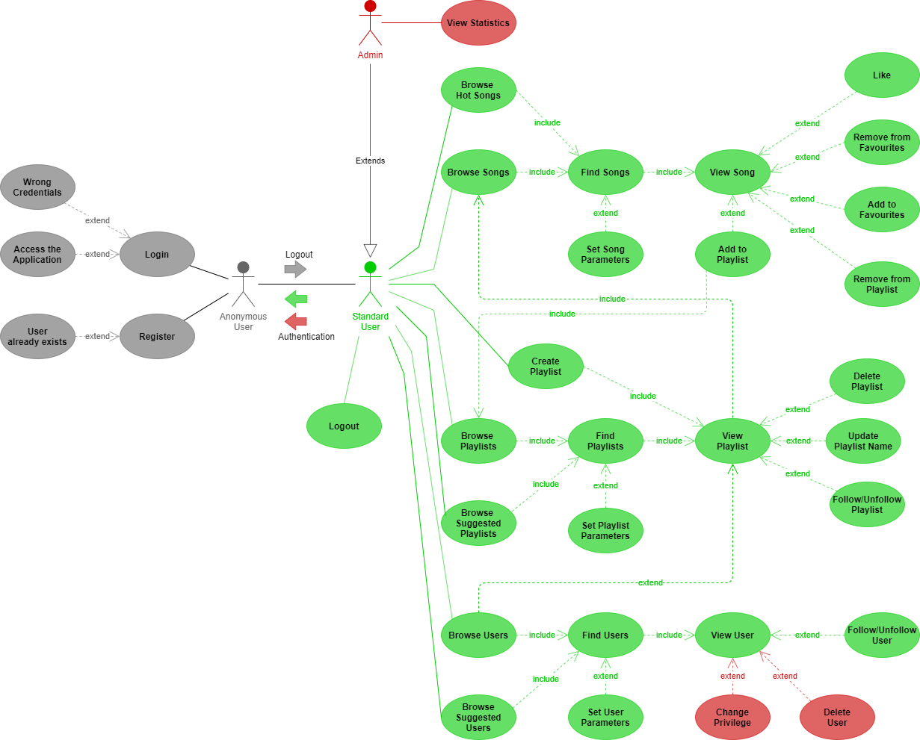

**Analysis Class Diagram**

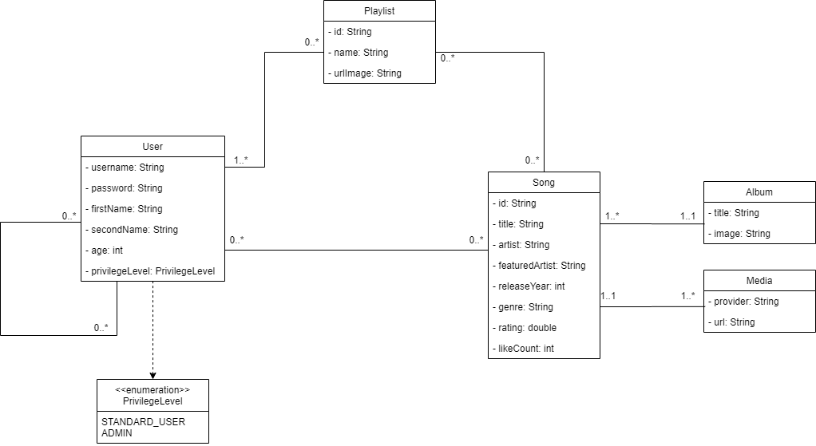

**Architectural Design**

**Software Architecture**

The application has been divided into *two-tiers* according to the *Client-Server* paradigm, exploiting **Java** as the core programming language.

Client Side

The client side is divided into:

* + A *Front-End* module, in charge of
    - providing a **GUI** based on **JavaFX** for users to interact with the application.
    - communicating with the underlying middleware to retrieve information obtained by processing data stored on server side.
  + A *Middleware* module, which communicates with the server side. It includes the logic used to communicate with the **MongoDB** cluster and the **Neo4j** database on the server, plus all the logic needed to handle and process data retrieved so that it can be used by the front end to present it to users.

Server Side

**Server** composed of 3 virtual machines which hosts a MongoDB cluster and a single instance of the Neo4j database.

Architecture Diagram

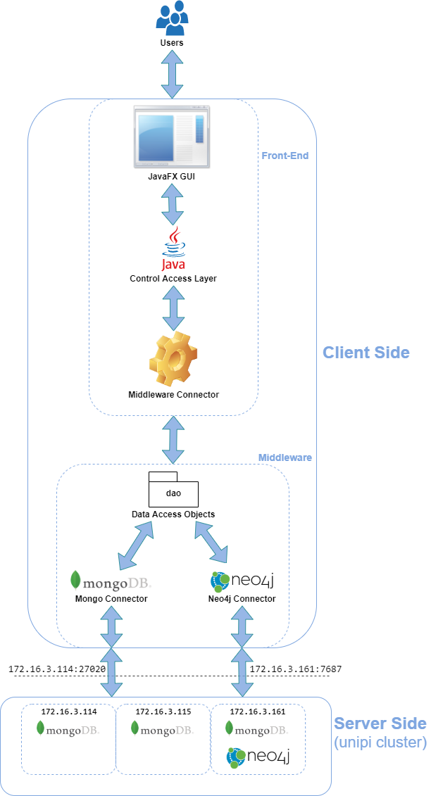

**Dataset Organization and Database Population**

**Song information**

The application dataset is manly composed by songs’ information, that are the core of our application.

They have been collected through multiple steps and multiple sources to respect the ***variety constraint***.

Firstly, we have obtained almost all the information using services offered by GENIUS ([www.genius.com](http://www.genius.com)), that permits to scrape their content through HTTP-based API (all steps can be found here [www.docs.genius.com](http://www.docs.genius.com)).

It returns a raw json document for each song requested; we then filter all information needed, in particular also 2 URLs and a URI that are used to scrape remaining information:

* using the Genius URL to the specific song page, we scrape the attribute “genre” that is not provided through API.
* using the Spotify URI, we have requested, through Spotify API, the song’s popularity.
* using the YouTube URL to the official video of the song we scrape the number of Like and Dislike.

The two last information have been used to create our “popularity” attribute as an aggregation of Spotify popularity and YouTube Like/Dislike ratio using this formula:

*0.7 * SpotifyPopularity + YouTubeRatio * 0.3.*

**User and playlist information**

Since our application is also a kind of social network, it is important for it to contain a satisfying number of users and playlists created by users. For this reason, we populate our databases using a script that randomly creates a high number of users, playlists, “follow” and “like” relations among them.

Here we have a summary of how the two databases are populated:

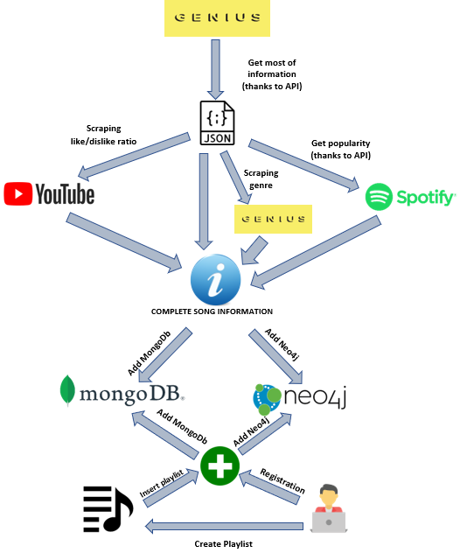

**Selected NoSQL Databases**

We decided to exploit a *Document* *Database* with **MongoDB** to store informations about entities composing our application dataset and make use of *document embedding* in order to *simplify* and *speed up* the execution of some statistical queries.

We then made the choice of exploiting a *Graph Database* with **Neo4j** to represent the *“network”* part of our application, using it also for the purpose of giving *suggestions* based on the network’s connections.

**MongoDB Design and Implementation**

Information about songs, users and playlists are stored in MongoDB in two different collections.

**User Collection**

The document of a user contains all the information about the account and an ***array***

***of embedded documents*** describing the playlists created by the user; it has been decided to embed the *playlist document* inside the *user collection* due to the *one to many* relationship between those two entities and to improve the ***performances*** of some of the analytics.

In each playlist are stored information about songs that have been added to it by the user; such information is a ***subset*** of the totality stored for each song, which can be found in the corresponding ***song document***.

This redundancy was chosen to improve the ***read performances***, so that we can give a simple preview of all the songs contained inside specific playlists without immediately retrieving all its information with a second read on the song collection.

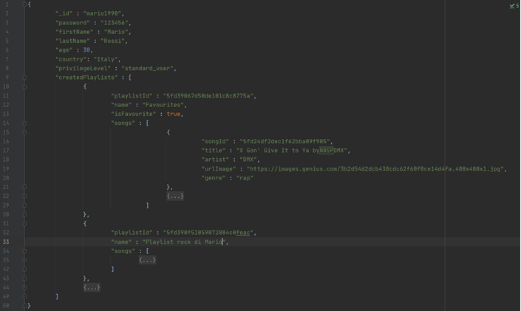

Such collection is also used for *login* purposes (e.g. checking if the password is correct).

**Song Collection**

The document of a song contains all information obtained by the scraping.

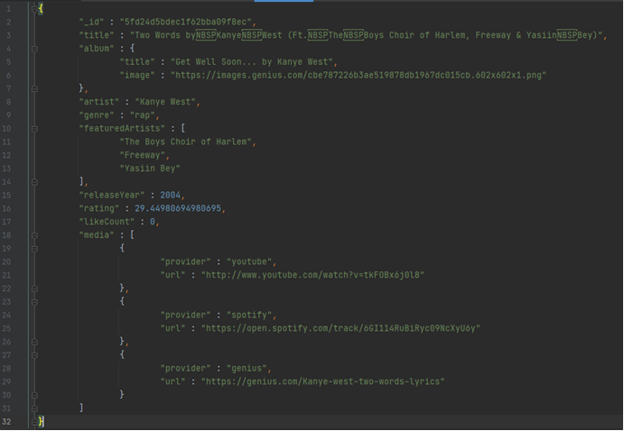

**CRUD operations**

**Create**

The functions used to create Users, Songs and Playlists are these:

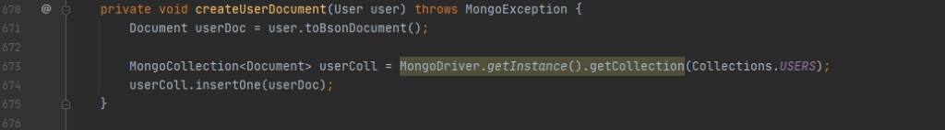

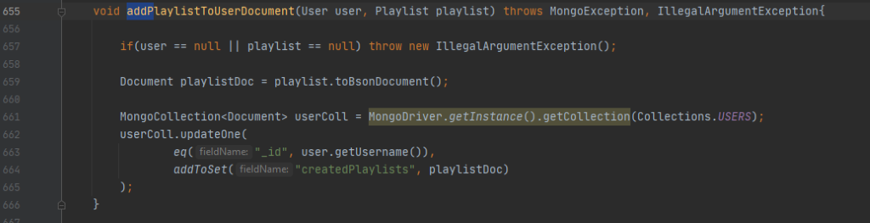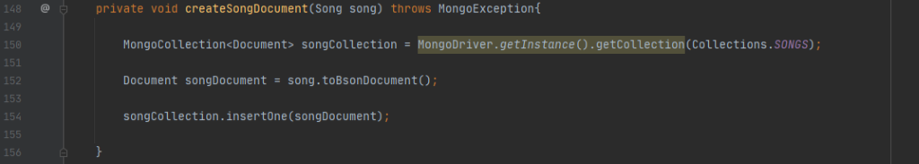

**Read**

The functions used to get the Users, Songs and Playlists using the id are these:

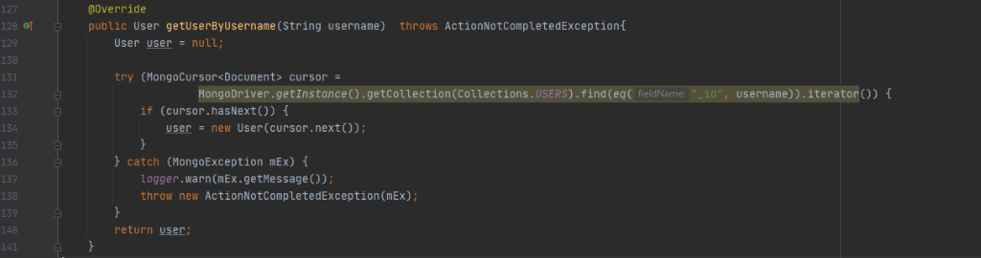

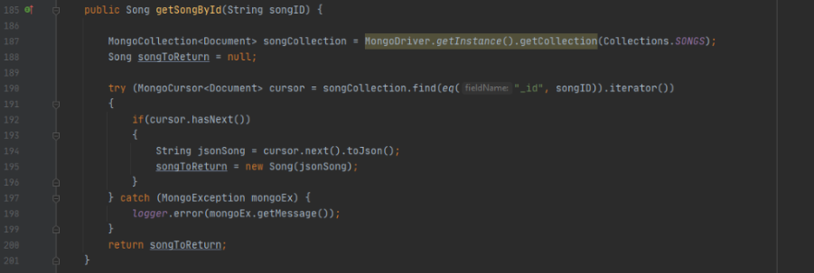

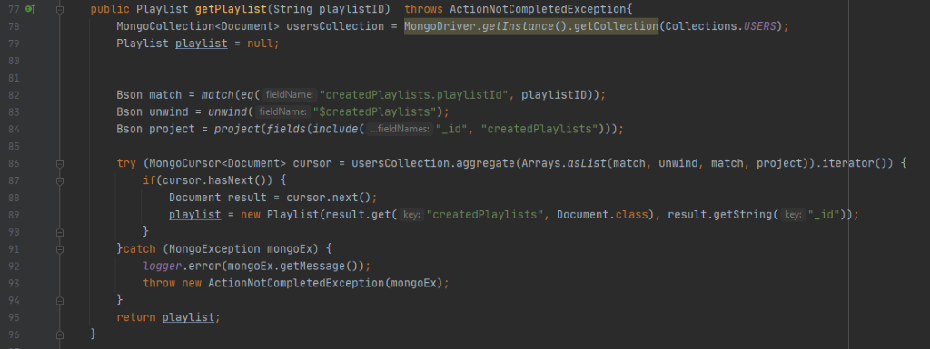

To retrieve all the playlists created by a user there is the function *getAllPlaylist*:

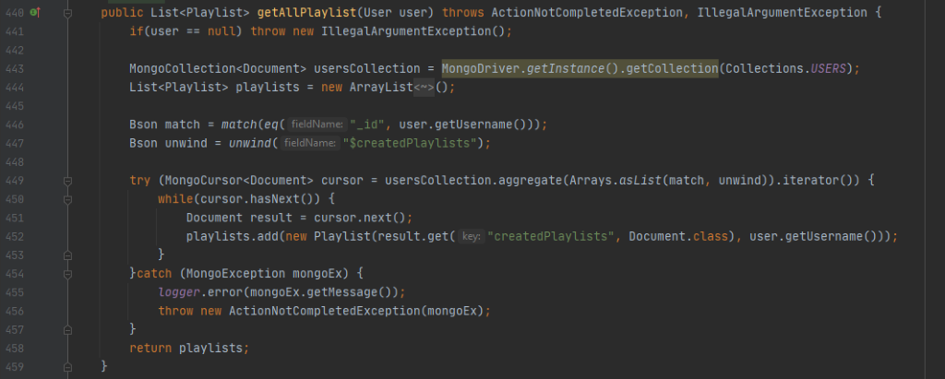

A user can search other users using the search bar thanks to the function *getUserByPartialUsername*:

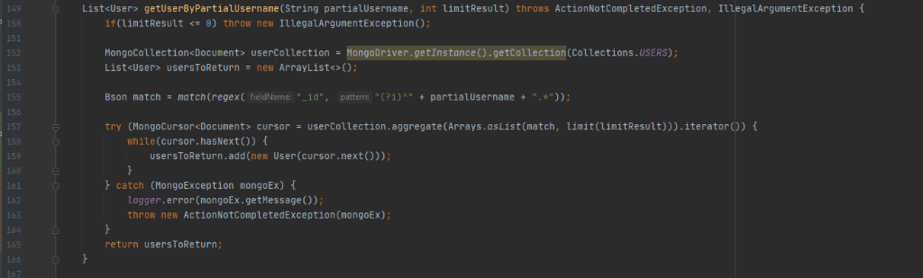

The function to retrieve all the songs of a playlist is the following:

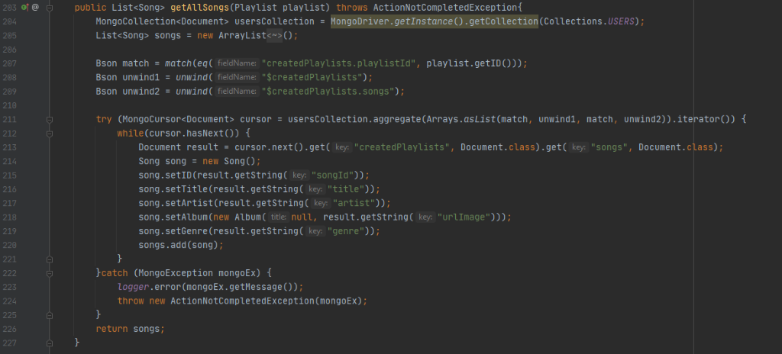

In the same way a user can use the search bar to search for songs by title, artist or album, specifying the correct parameter for attributeField using the *filterSong* function:

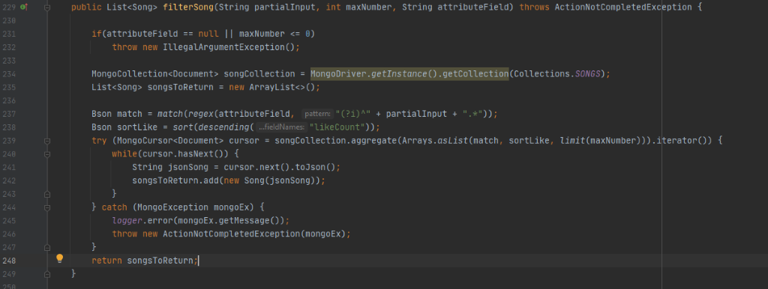

*checkUserPassword*is used when there is the check of the credentials inserted in the login form:

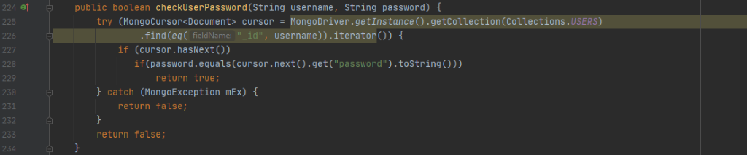

**Update**

The function *addSong* is used to add a song to a playlist specified by its id:

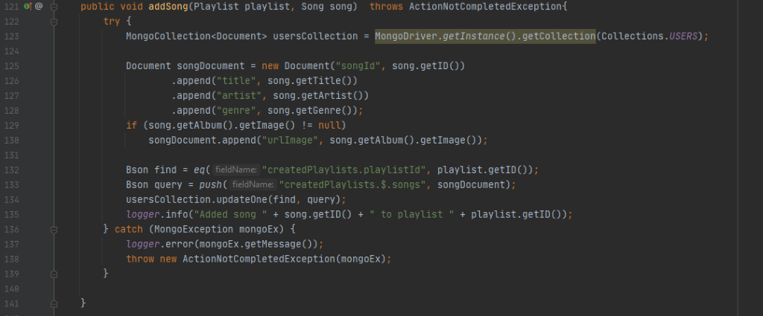

When a user puts a *like* to a song, the document of the song needs to be updated to maintain the ***redundancy*** *$likeCount*, the function used in this situation is the following (there is an analogue function when a like is removed):

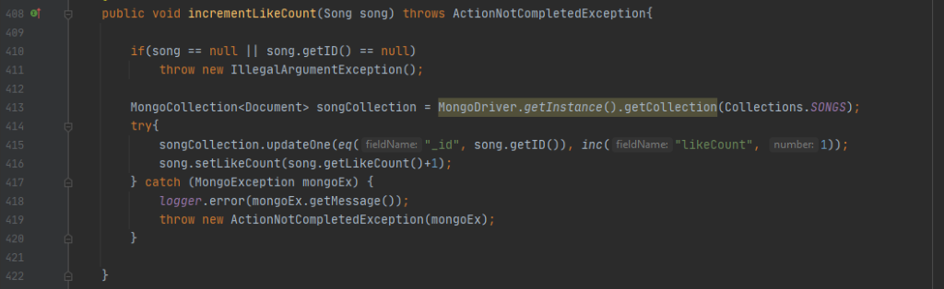

An admin can update the privilege level of a user:

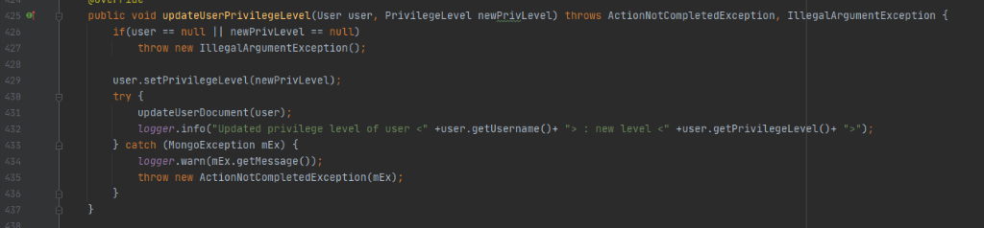

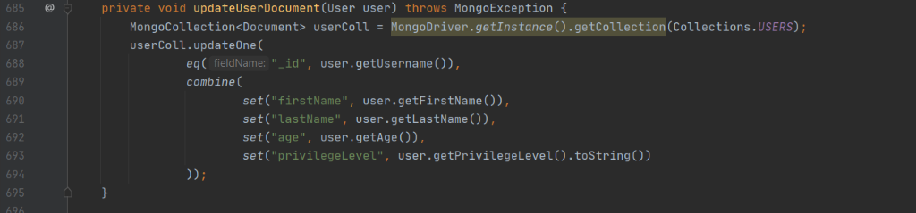

**Delete**

An admin can delete a user:

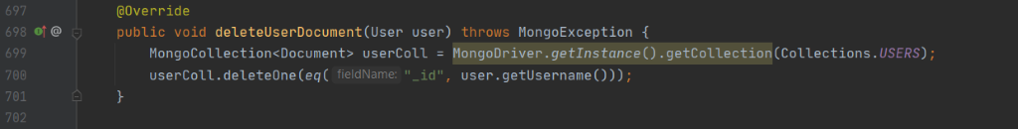

A user can delete its own playlists using the function:

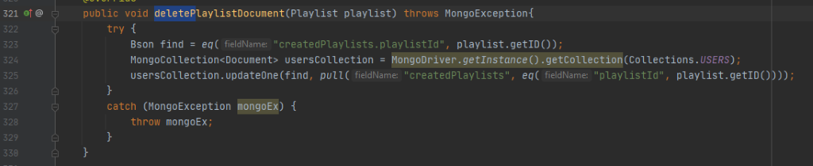

**Queries Analysis and MongoDB Connection String**

***Write operations*** results *less frequent* and generally simple (at most one document created or updated at a time) while, on the opposite, ***Read operations*** are more frequently performed and involve a higher number of documents.

Furthermore, the system has *response time* and *availability* requirements, therefore it is tuned as follow:

* **Write Concern**: 1. This allows the system to be as fast as possible during write operations, introducing the need to implement some kind of ***Eventual Consistency paradigm***.
* **Read Preferences**: nearest. Read operations are performed on the node with the lowest network latency to have the fastest response.

To set those options, the following connection string is used in the MongoDB Java Driver:

mongodb://172.16.3.115:27020,172.16.3.114:27020,172.16.3.161:27020/?w=1&readPreference=nearest

**Analytics and Statistics**

In the following the four pipelines aggregations used to extract interesting information from data are described.

**Artists with Most Hit Songs**

**Description:** Select artists which made the highest number of “hit songs”.

A song is a “hit” if it received more than ”*hitLimit*” likes.

**Mongo java driver:**

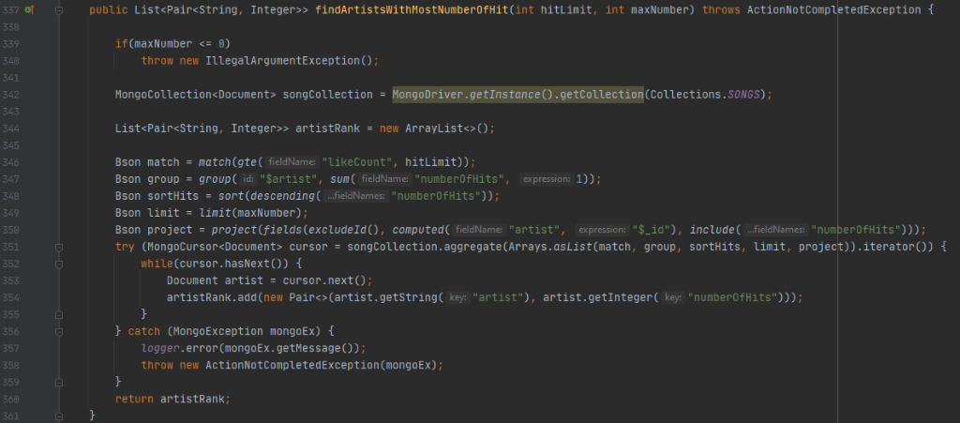

**Mongo** with “*hitLimit*” = 0, “*maxNumber*” = 5**:**

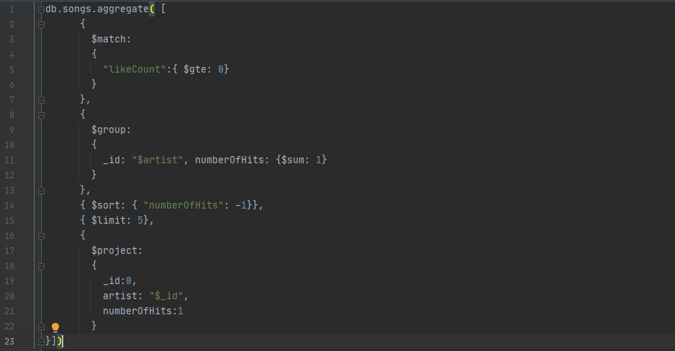

**Top Rated Album per Decade**

**Description:** For every decade, select the album with the highest average of rating.

**Mongo java driver:**

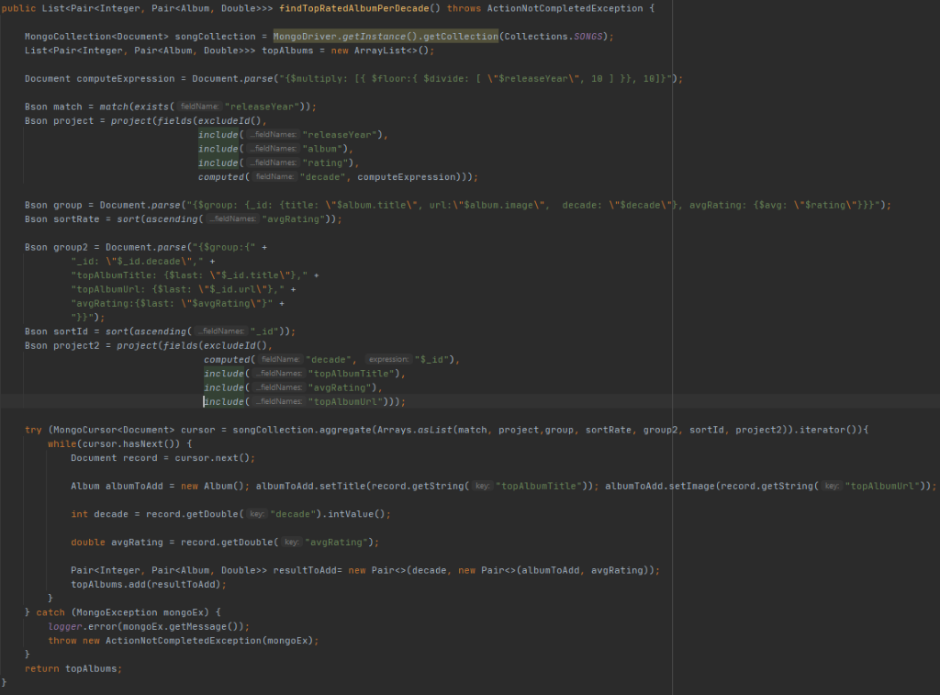

**Mongo:**

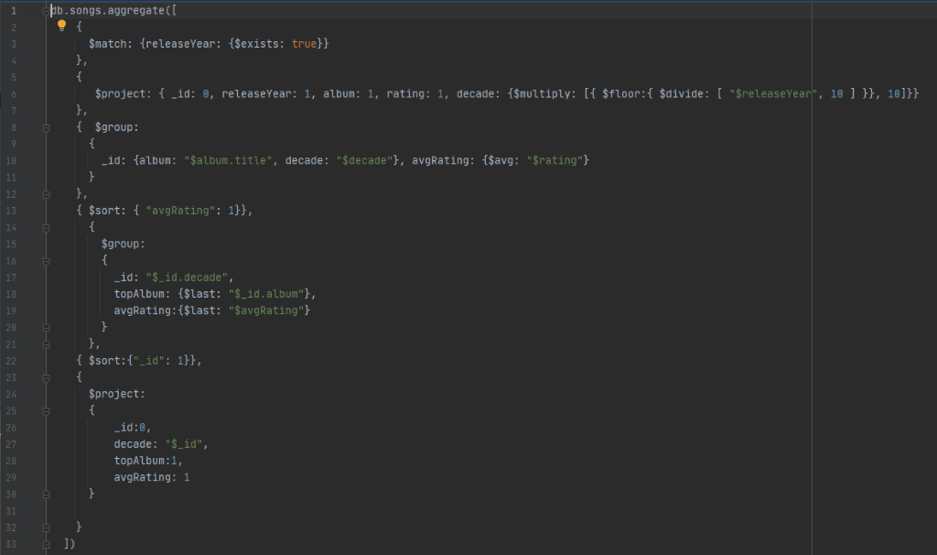

**Top Favourite Genres**

**Description:** Select the top favourite genres of users. A genre is the favourite of a user if it is the most present genre in his playlists.

**Mongo java driver:**

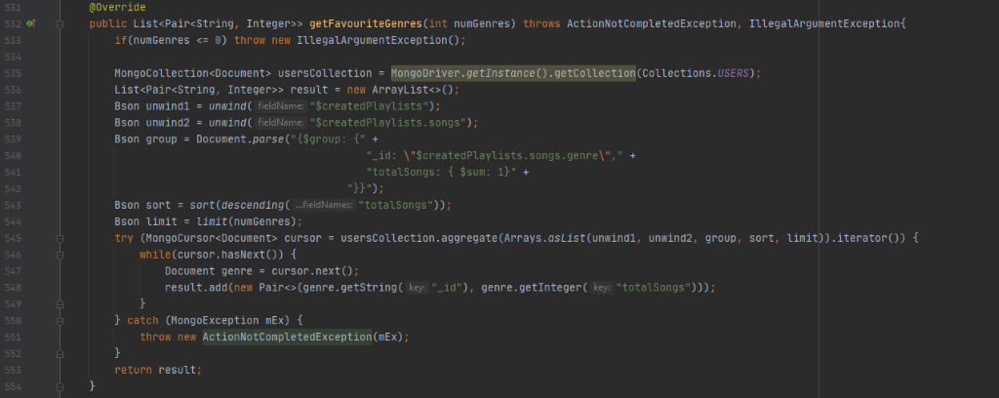

**Mongo with** “*maxGenres* = 3”**:**

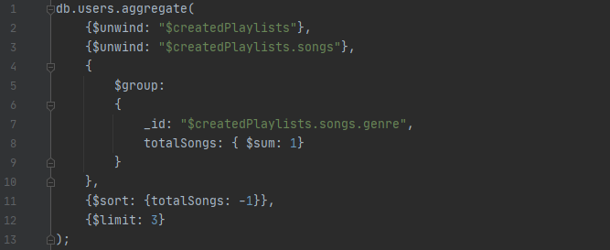

**Top Favourite Artist per Age Range**

**Description:** Select the top artist per age range.

**Mongo java driver:**

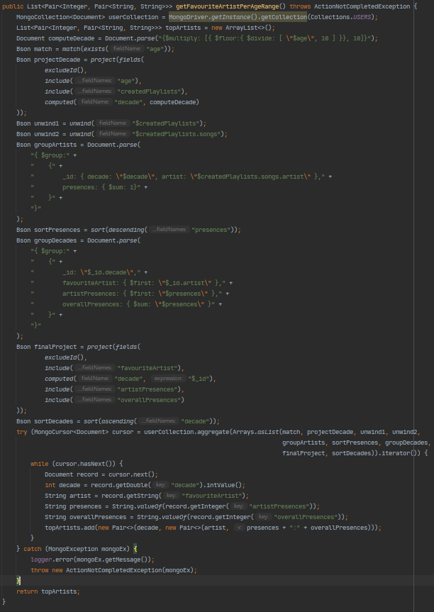

**Mongo:**

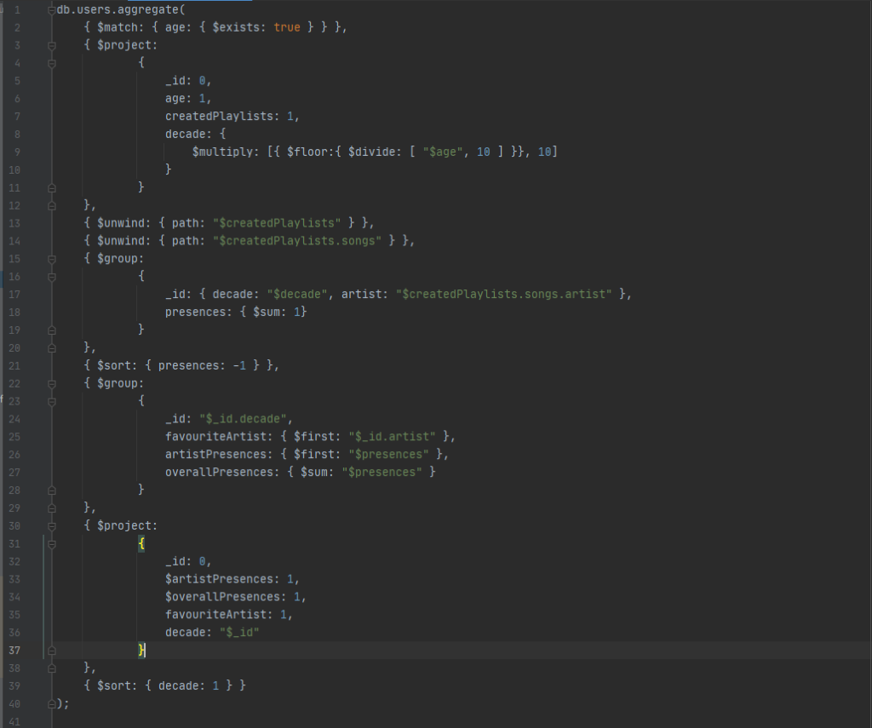

**Indexes Analysis**

In order to enhance the read operations on the database, the following indexes were introduced:

|  |  |  |  |
| --- | --- | --- | --- |
| **Index Type** | **Collection** | **Index Name** | **Index Field** |
| **Hashed Index (default)** | songs | *id* | _id |
| **Simple index** | songs | title | title |
| **Simple index** | songs | artist | artist |
| **Simple index** | songs | album | album.title |
| **Hashed Index (default)** | users | *id* | _id |
| **Simple index** | users | playlist | createdPlaylist.playlistId |

They are useful to improve the main queries that are executed more frequently:

* *title*, *artist* and *album* whenever the search bar is used (*filterSong)*.
* *playlist* whenever is displayed the page of a playlist (*getPlaylist*).

**Index “artist”**

Below is shown the improvement with the equality match between a **partial artist’s name** and a **regular expression**.

As we can see were examined all the documents (124561), while with the index just the right documents that match the regular expression (6212) are examined.

Consequently, the **execution time** decrease very much: from 82 to 15 milliseconds.

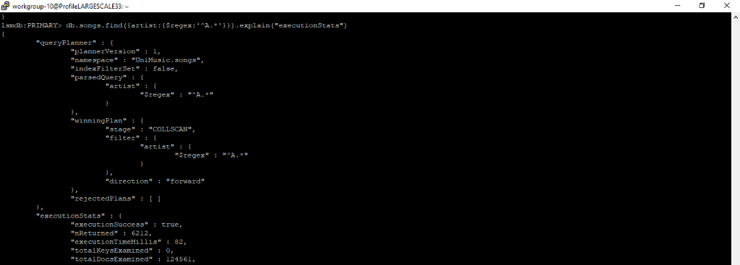

Without artist Index

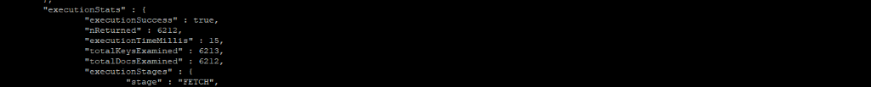 With artist Index

**Index “album”**

Below is shown the improvement with the equality match between **a partial album’s title** and a **regular expression**.

As we can see were examined all the documents (124561), while with the index just the right document that match the regular expression (6188) are examined.

Consequently, the **execution time** decrease very much: from 86 to 16 milliseconds.

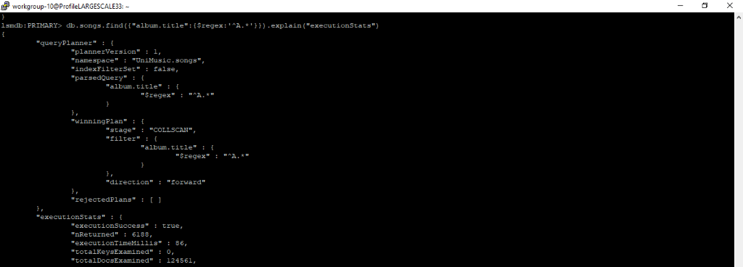

Without album Index

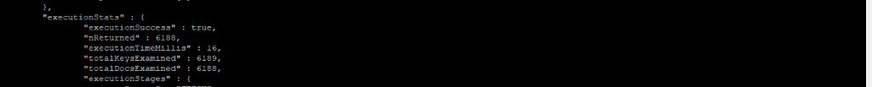 With album Index

**Index “title”**

Below is shown the improvement with the equality match between a **partial song’s title** and a **regular expression**.

 As we can see were examined all the documents (124561), while with the index just the right document that match the regular expression (6619) are examined.

Consequently, the **execution time** decreased very mush: from 81 to 18 milliseconds. 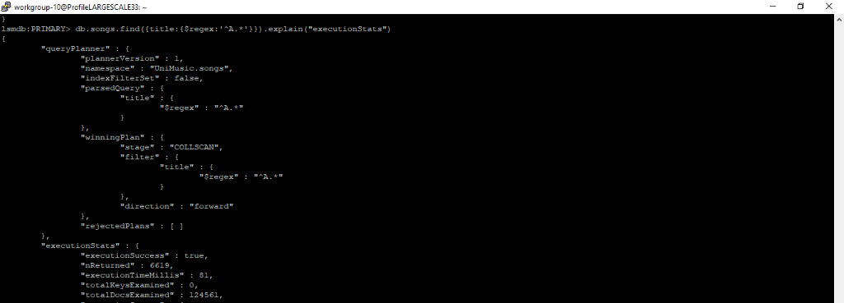

Without title Index

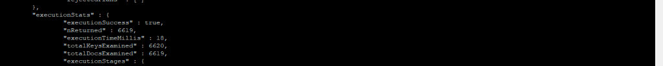 With title Index

**Index “playlist”**

Below is shown the improvement when we **retrieve a playlist** specifying the ID.

As we can see were examined all the documents (13745), while with the index just the correct one.

Consequently, the **execution time** decrease very much: from 20 to 0 milliseconds.

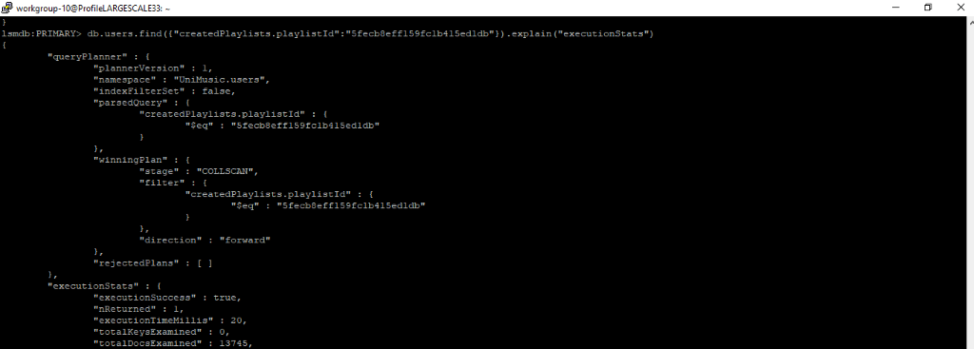

Without playlist Index

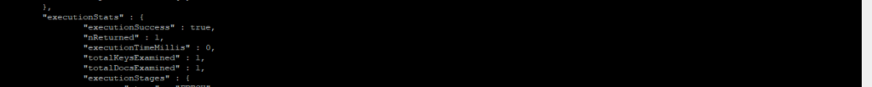 With playlist Index

**Neo4j Design and Implementation**

**Nodes**

There is a node for each **main entity** of our application, in particular (:Song), (:User) and (:Playlist).

They just contain **essential properties** needed to display a **preview** of the entity.

**Relations**

**USER - FOLLOW_USER -> USER:** this relation is added whenever a user adds another to his followed user list. It is useful to retrieve suggested playlist and suggested user.

**USER - FOLLOW_PLAYLIST -> PLAYLIST:**this relation is added whenever a user saves another user’s playlist to his playlist’s list. It is useful to retrieve suggested playlist and to have always handy in the user’s profile followed playlists. It is important to note that it is just a link to the playlist, so if the author modify or delete it, this action will affect the playlist saved on our profile.

**USER - LIKES -> SONG:**this relation is added whenever a user likes a song. It is useful to retrieve hot song (that also use the relation attribute “day”) and the second layer of suggested user.

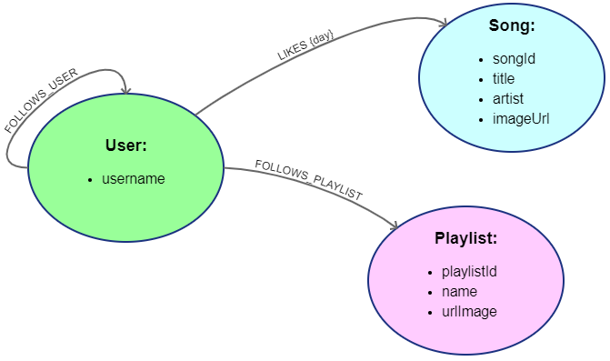

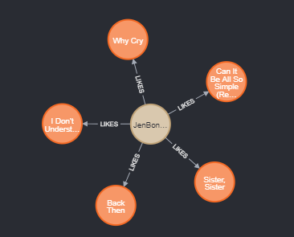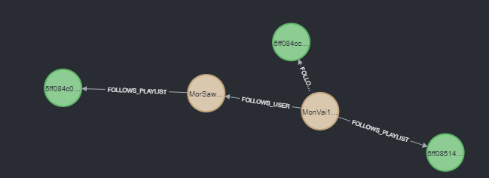Two screenshots of the Neo4j database are shown below:

**Queries Implementation**

**CRUD Operations**

The following tables contain a collection of all the **CRUD operations** done within the application, along with **their Cypher implantation**.

**Create**

|  |  |
| --- | --- |
| Operation | Cypher Implementation |
| Create a user node | **MERGE** (a:User {username: $username}) |
| Create song node | **CREATE** (p:Song {songId: $songId, title: $title, artist: $artist, imageUrl: $imageUrl}) |
| Create playlist node | **CREATE** (p:Playlist {playlistId: $playlistId, name: $name, urlImage: $urlImage}) |
| Add a FOLLOW_USER relation | **MATCH** (following:User { username: $following })  **MATCH** (followed:User { username: $followed })  **WHERE** following <> followed  **MERGE** (following)-[:FOLLOWS_USER]->(followed) |
| Add a LIKES relation | **MATCH** (u:User { username: $username })  **MATCH** (s:Song { songId: $songId })  **MERGE** (u)-[:LIKES {day: date()}]->(s) |
| Add a FOLLOW_PLAYLIST relation | **MATCH** (following:User { username: $following })  **MATCH** (followed:Playlist { playlistId: $followed })  **MERGE** (following)-[:FOLLOWS_PLAYLIST]->(followed) |

**Read**

|  |  |
| --- | --- |
| Operation | Cypher Implementation |
| Get total number of users | **MATCH** (:User) **RETURN** COUNT(*) AS NUM |
| Get total number of songs | **MATCH** (:Song) **RETURN** COUNT(*) AS NUM |
| Get total number of playlists | **MATCH** (:Playlist) **RETURN** COUNT(*) AS NUM |
| Operation | **Cypher Implementation** |
| Get all the playlist followed by a user | **MATCH** (:User {username: $username})-[:FOLLOWS_PLAYLIST]->(playlist:Playlist) **RETURN** playlist |
| Get all the user followed by a user | **MATCH** (:User {username: $username})-[:FOLLOWS_USER]->(followedUser:User) **RETURN** followedUser |
| Get all the follower of a user | **MATCH** (followingUser:User)-[:FOLLOWS_USER]->(:User {username: $username}) **RETURN** followingUser |
| Check if a user follows a specific playlist | **MATCH** (:User { username: $username })-[f:FOLLOWS_PLAYLIST]->  (:Playlist { playlistId: $playlistId })  **RETURN** count(*) AS Times |
| Check if a user is followed by a certain user | **MATCH**(:User { username: $following })-[f:FOLLOWS_USER]->  (:User { username: $followed })  **RETURN** count(*) AS Times |
| Check if a user likes a specific song | **MATCH** (:User { username: $username })-[l:LIKES]->(:Song { songId: $songId })  **RETURN** count(*) AS Times |

**Update**

|  |  |
| --- | --- |
| Operation | Cypher Implementation |
| Update the name of a Playlist | **MATCH** (:Playlist { playlistId: $playlistId }) **SET** name = $newName |

**Delete**

|  |  |
| --- | --- |
| Operation | Cypher Implementation |
| Remove a FOLLOW_USER relation | **MATCH** (:User { username: $username1 })-[f:FOLLOWS_USER]->  (:User { username: $username2 })  **DELETE** f |
| Remove a FOLLOW_PLAYLIST relation | **MATCH**(:User { username: $username })-[f:FOLLOWS_PLAYLIST]->  (:Playlist { playlistId: $playlistId })  **DELETE** f |
| Remove a LIKE relation | **MATCH** (:User { username: $username })-[l:LIKES]->(:Song { songId: $songId }) **DELETE** l |
| Delete a user node | **MATCH** (a:User {username: $username}) **DETACH DELETE** a |
| Delete playlist node | **MATCH** (p:Playlist { playlistId: $playlistId }) **DETACH DELETE** p |

**“On-graph” queries**

**Suggested User**

Using Neo4j we are able to find **two levels** **of** **suggested user.**

|  |  |
| --- | --- |
| Graph-Centric Query | Domain-specific Query |
| Considering only vertices that takes only 1 hop from vertex “User A” using edge “FOLLOW_USER”, select all vertices that take 1 hop from them using edge “FOLLOW_USER”. | Who are the users that are followed by user that “User A” follows? |
| Find the vertices “User X” that reach the highest number of vertices Song with the edge “LIKES”, where the same vertex Song is reached by “User A” with the edge “LIKES”. | Who are the users that have the highest number of likes in common with “User A”? |

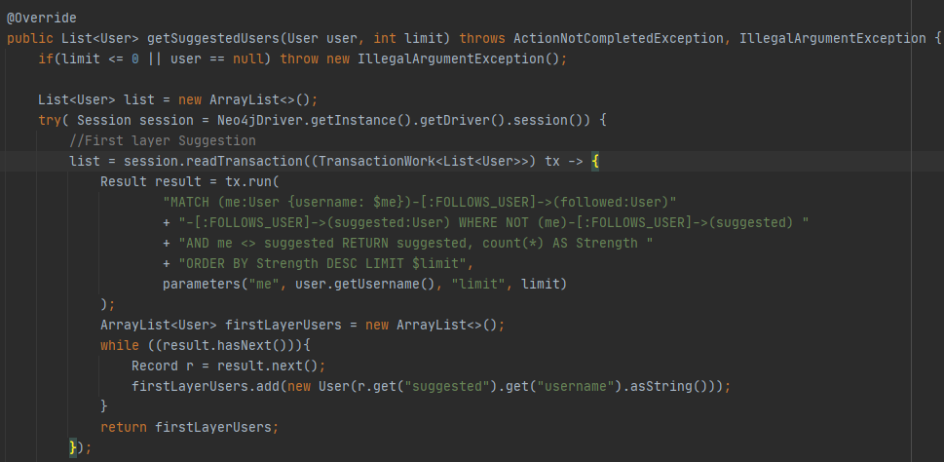

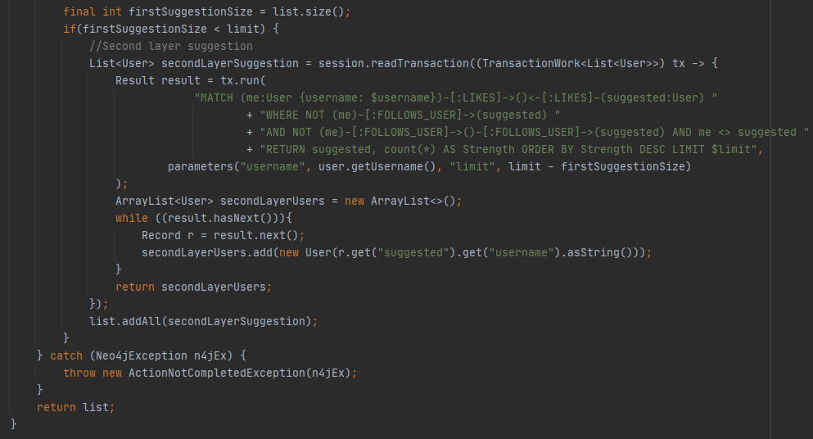

**Suggested Playlist**

Using neo4j we are able to find two levels of **suggested Playlist.**

|  |  |
| --- | --- |
| Graph-Centric Query | Domain-specific Query |
| Considering only vertices that takes only 1 hop from vertex “User A” using edge “FOLLOW_USER”, select all vertices that take 1 hop from them using edge “FOLLOW_PLAYLIST”. | Which are the Playlists that are followed by user that “User A” follows? |
| Considering only vertices that are selected by first layer of User suggestion, select all vertices that take 1 hop from them using edge “FOLLOW_PLAYLIST”. | Which are the Playlists that are followed by User that are followed by User that “User A” follows? |

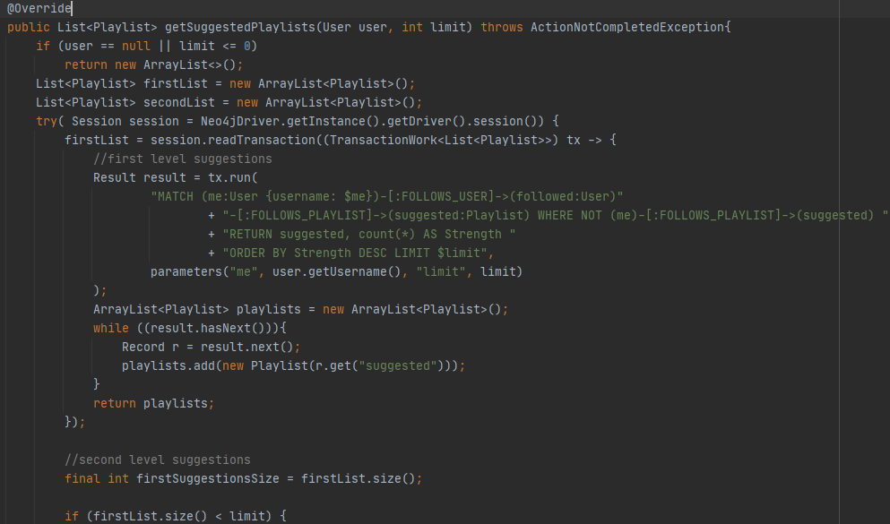

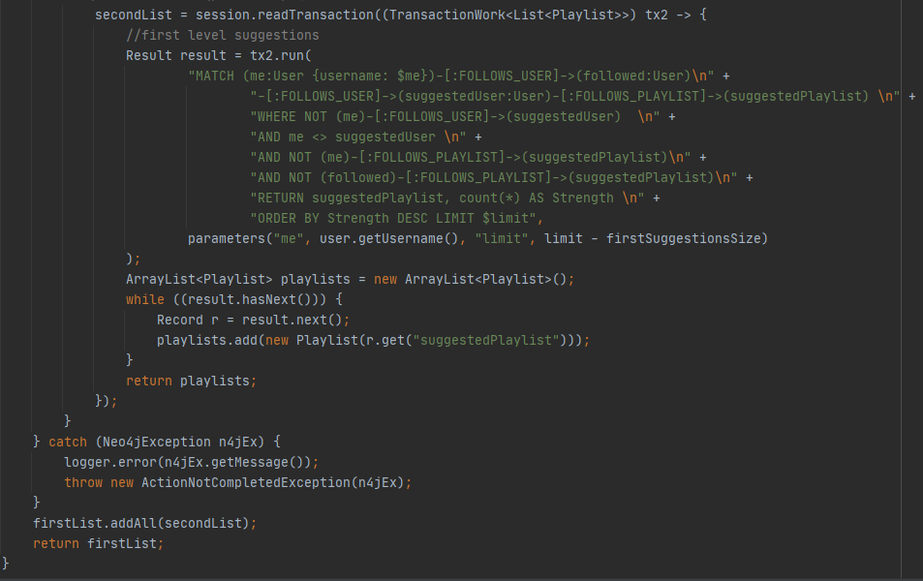

**Hot songs**

Using neo4j we are able to find songs that received the **highest number of likes in the last month.**

|  |  |
| --- | --- |
| Graph-Centric Query | Domain-specific Query |
| Which are the Songs with the highest number of incoming edge “LIKES” that has the property “*day”* contained in the last 30 days? | Which are the songs that received the highest number of likes in the last month? |

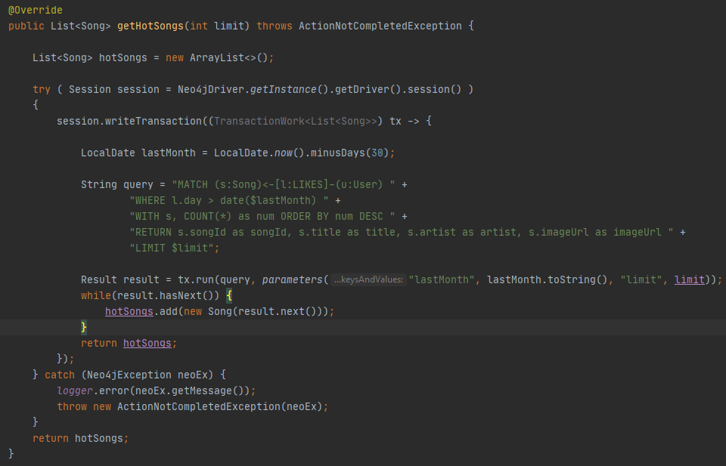

**Neo4j Indexes**

In order to **enhance the read operations** on the database, the following indexes were introduced to find the **starting point** of a **graph traversal**:

|  |  |  |  |
| --- | --- | --- | --- |
| **Index Type** | **Index Name** | **Index Label** | **Index Attributes** |
| **BTREE (simple index)** | User_index | :User | username |
| **BTREE (simple index)** | Playlist_index | :Playlist | playlistId |



**Other Implementation Details**

**Shards Configuration and Non-Functional Requirements**

According to the *Non-Functional Requirements*, the system must provide *high availability*, *fast response times* and be *tolerant to data lost* and *single point of failure*.

To obtain such results, we decided to orientate our application on the ***A*** (Availability) ***P*** (*Partition Tolerance*) edge of the CAP triangle, therefore having the need to adopt the *Eventual Consistency* paradigm on our dataset. This choice leds to make the content of the application highly available, even if an error occur on the physical network, at the cost of returning to the user data that is not always accurate.

The possibility to implement a sharding for the of the database would allow to further reduce the latency/response time for server interactions, improving user experience.

In that regard, we thought to partition the *document database* in shards hosted each one on a different erver. Such ***sharding***, together with the already implemented *data* ***replication***, would allow for ***load-balancing*** purposes, achieving the characteristics required by the ***Non-Functional Requirements***.

To implement such sharding, we would select two different ***sharding keys*** and ***partitioning method***, one for each collection of our document database (*User Collection* and *Song Collection*):

* For the **User Collection** we decided to choose the attribute “*country*” as a ***sharding key*** and as a ***partitioning method*** we choose a *List*, to map each country to a specific server in a way to further reduce the response time such mapping should be done in a way to balance the load on servers.
* For the **Song Collection** we decided to choose the attribute “*_id*” as a ***sharding key*** and as a  ***partitioning method*** we choose a *Hashing*, eventually applying *Consistent Hashing* to relocate data when a server goes down or a new server is added.

**Cross-Database Consistency Management**

The operations that require a cross-database consistency management are the Add/Remove a Song/User/Playlist and Add/Remove a like to a song:

* **Considering the add $entity**, if an error occurs with the first write operation, we just log the error in errors.txt file, while if an error occurs with the second write operation, we also try to delete the preceding write operation, beyond log the error.
* **Considering the remove $entity**, we first remove the document from MongoDb, but if an error occurs in Neo4j we do not add again the document in Mongo, but we just log the error.
* **Considering the adding/remove like to a song**, we first remove the edge in Neo4j, but if an error occurs the second write operation in MongoDb we do not add again the edge in Neo4j, but we just log the error.

**Administrators** **oversee**manually check and **enforce consistency** where problem(s) have occurred to restore the consistency.

**ADD AN $ENTITY (Song, User or Playlist)**

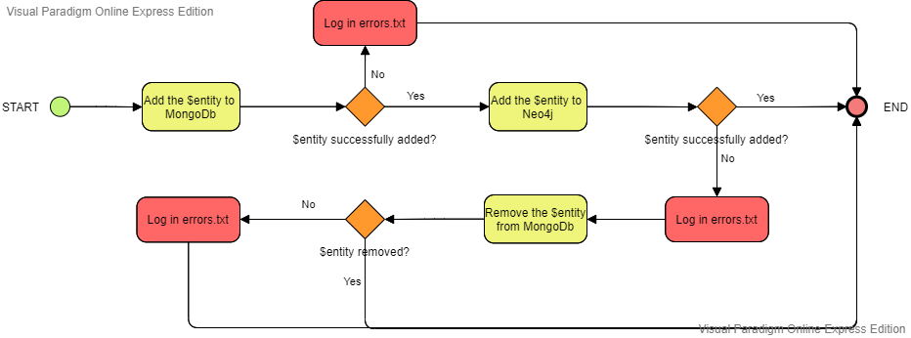

**REMOVE AN $ENTITY (Song, User or Playlist)**

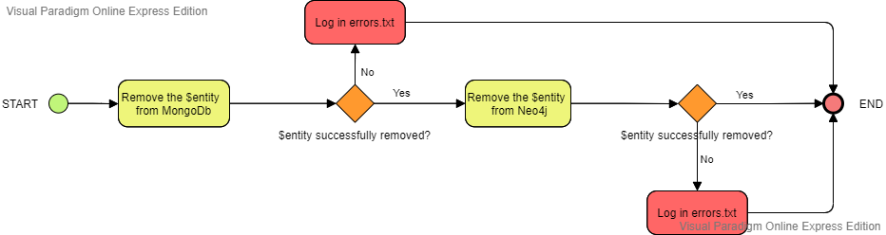

**ADD/REMOVE A SONG’S LIKE**

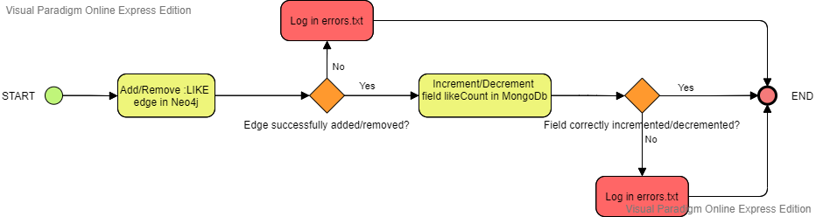

**Application Package Structure**

The final implementation of the Java application project consists of 3 main packages:

* ***databasePopulation***: contains files used for the *Scraping.*
* ***frontend***: contains all the files used to manage the *Graphical User Interfaces* and also the *MiddlewareConnector* file used to give an access interface to the underlying middleware logic.
* ***middleware*** contains:
  + the logic needed to connect to used databases (***persistence*** package).
  + the logic needed to exploit such connection to perform operations required from the *frontend*. In particular, it contains all the *Model Objects* (***entities***), the *Data Access Object Interfaces* and their *Concrete Implementations* (***dao***).
  + a *Logger* used to classify and maintain log information.

|  |  |  |  |  |
| --- | --- | --- | --- | --- |
| |  | | --- | |  | |  | |  | |  |

We also have done some **test unit**, that can be found in the following package:

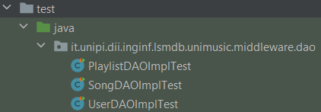

**User Manual**

**Login and registration**

Once the application is started, the first screen shown to the user contains the forms to **log in** and to **register a new account.**

If a user accesses the application for the first time, he needs to register a new standard user account using the form on the right. After that, he can insert his credential on the left to log in.

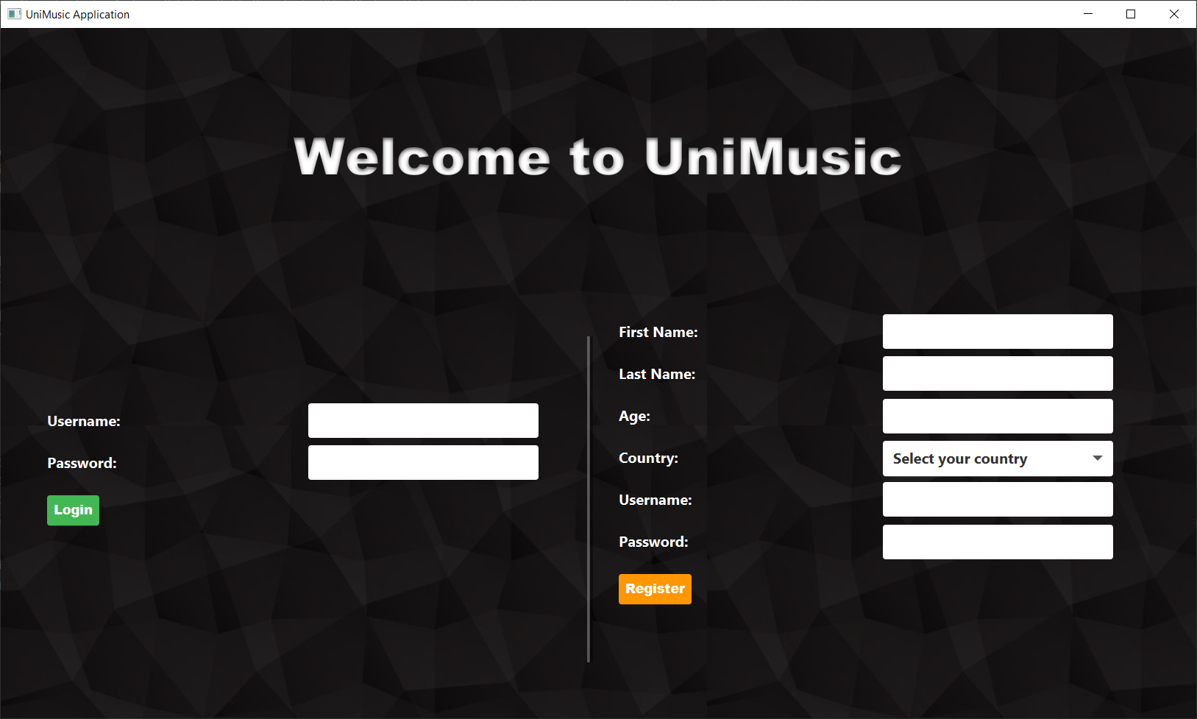

Pic. 1 Log in and registration page

**Home page**

For a standard user, the homepage is the following:



Pic. 2 Homepage

**Side bar**

On the left there is a **side bar** (equal for every screen of the application), used by the user to:

* visualize its homepage(Home).
* visualize its playlist of favourite songs (Favourites).
* add a new playlist (Add Playlist).
* access to his own profile (Profile).
* log out and return to the login page (Logout).

**Body**

At the centre of the page there are shown:

* **hot songs,** i.e. the songs which received more like in the last month.
* **suggested playlists,** i.e. the playlist followed by our followed user or by the user followed by them.
* **suggested users,** i.e. users followed by our followed users and users which like the same songs as us.

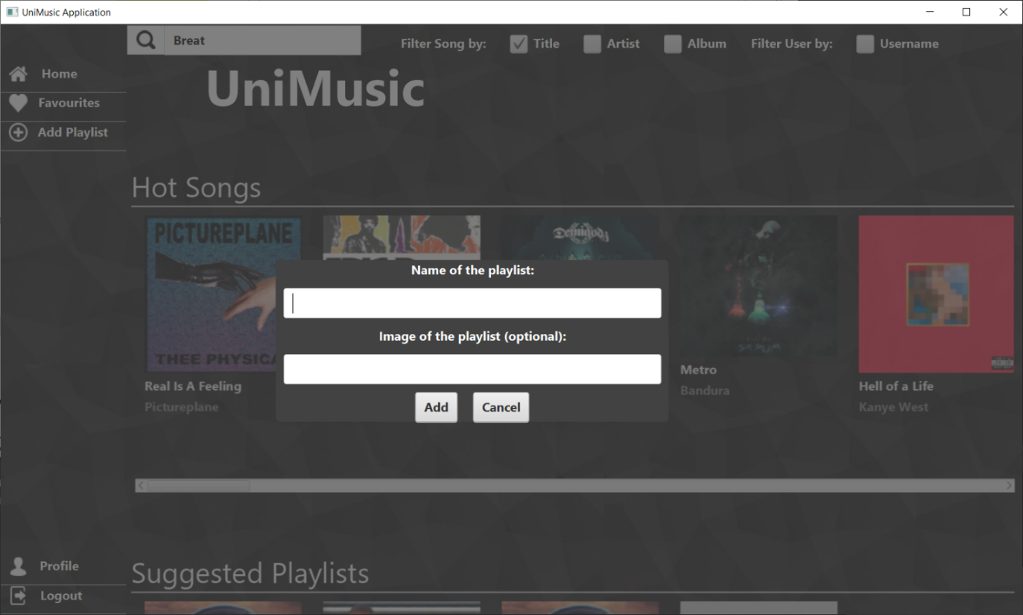

Pic. 3 Form to create a new Playlist

**Search bar**

At the top of the screen there is a search bar (also the same for all screens) where the user can search for **songs or users**.

The type of search is differentiated by the use of the **checkboxes**, the user has to insert the title of the song, the name of the artist or the name of the album to find songs depending on which box is checked between Title, Artist or Album, otherwise he can search for other users ticking the checkbox Username.

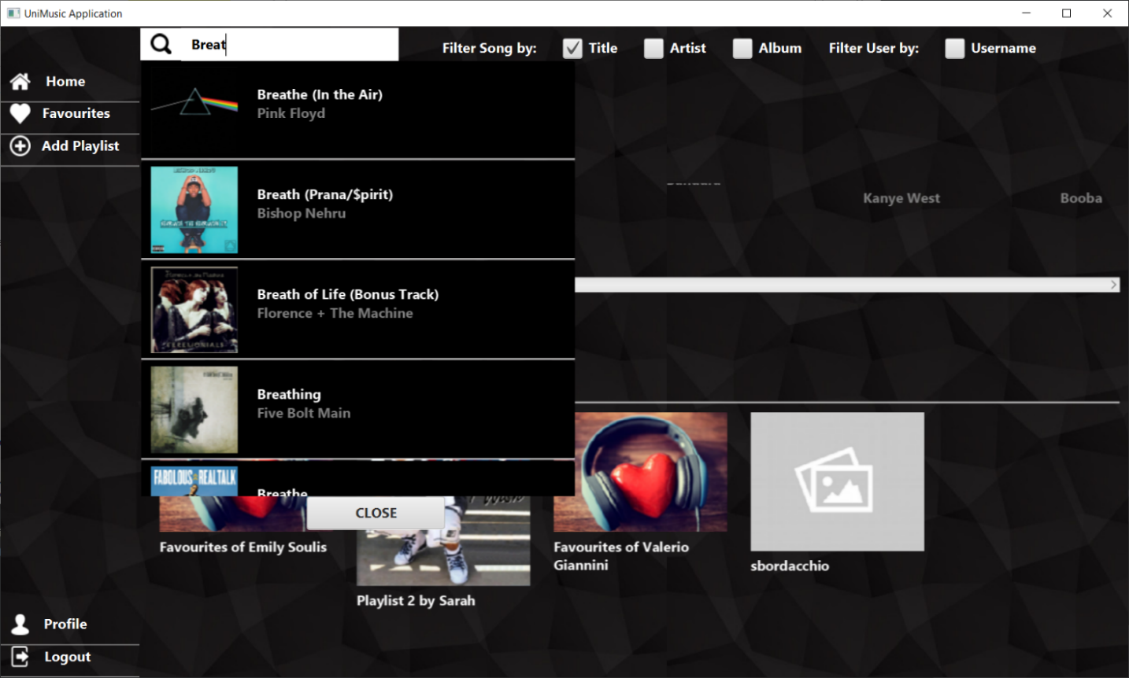

Pic. 4 Use of the search bar

**Song page**

The page of a song contains his information, buttons to add the song to favourites, to add song to a playlist and to like the song.

It is also shown a rating, based on the popularity on Spotify and the number of like and dislike on YouTube. Below there are the links to YouTube, Spotify and Genius, and by clicking on them the user can listen the song or view its video on his browser.

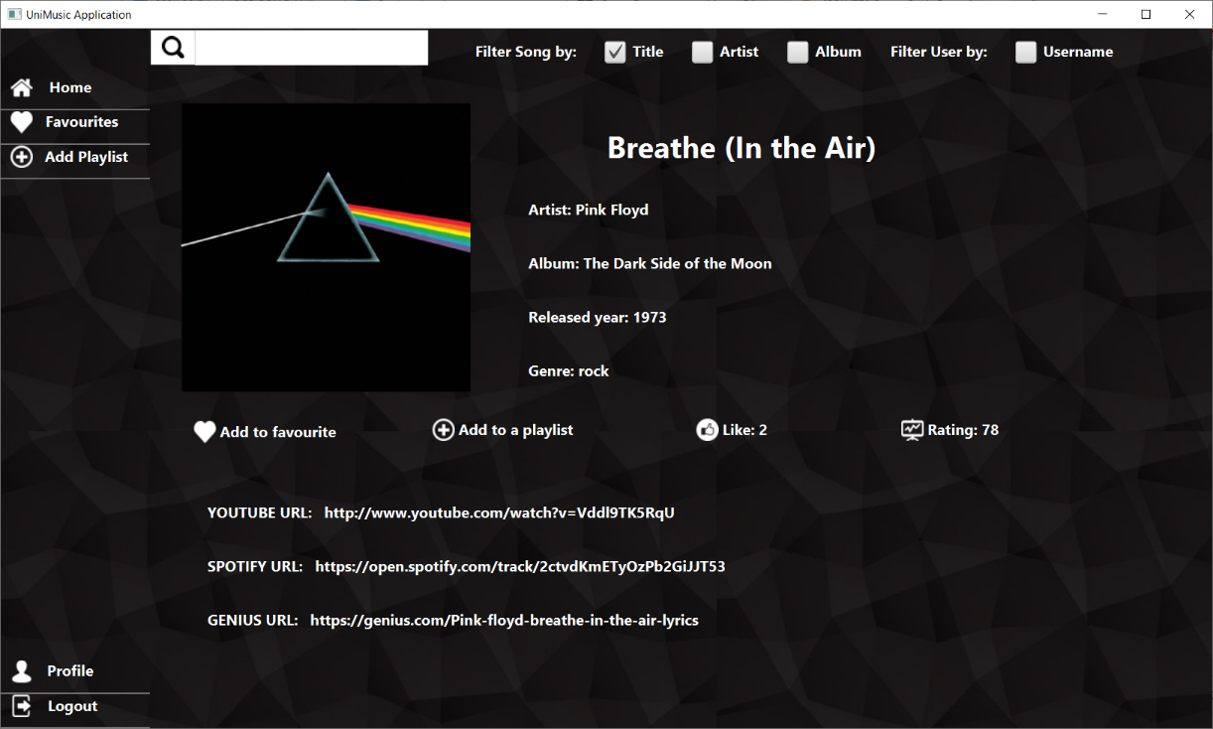

Pic. 5 Song page

**User Page**

The page of a user gives the possibility to follow him, to see his playlists and follow them, and to see and follow the follower and the followed user of that profile. If the user shown correspond to the logged user, he has the possibility to the delete his own profile.



Pic. 6 User page

**Playlist Page**

The playlist page shows the information of the playlist and all the songs it contains, and it gives the possibility to like them and to reach the correspondent song page. If the playlist is created by the logged user, he has the possibility to delete it.

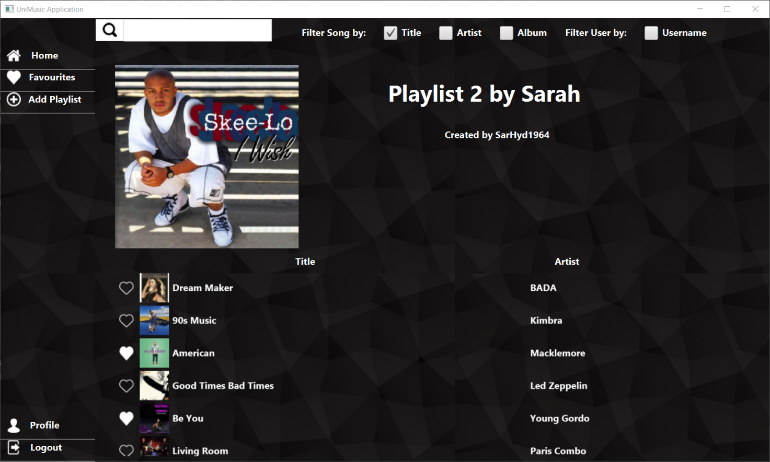

Pic. 7 Playlist page

**Admin**

If the credentials inserted in the login form are associated to an Administrator account, the user can access to some extra functionalities of the application.

The sidebar of an administrator gives the possibility to access to the statistics of the application

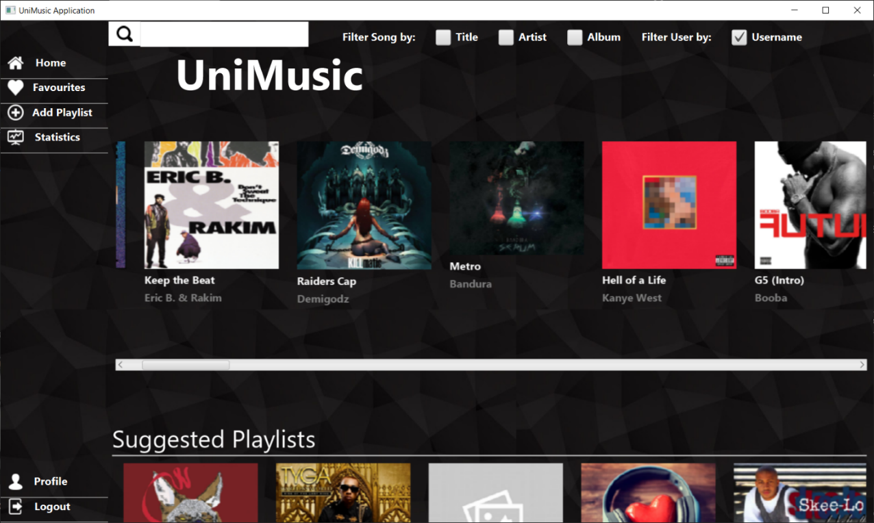

Pic. 8 Homepage for an Administrator

From the statistics page the admin can:

* Check the number of users, songs and playlists saved in the database.
* View the artists which made the higher number of hits (songs that received more than Hit Threshold likes, which is a customizable parameter for the admin).
* View the most rated albums for every decades.
* View the most present genres in playlists.
* View the favourite artists for every age range.



Pic. 9 Statistics page

If an admin goes to a user page, he has the possibility to delete his account and to update his privilege level to the Administrator level:

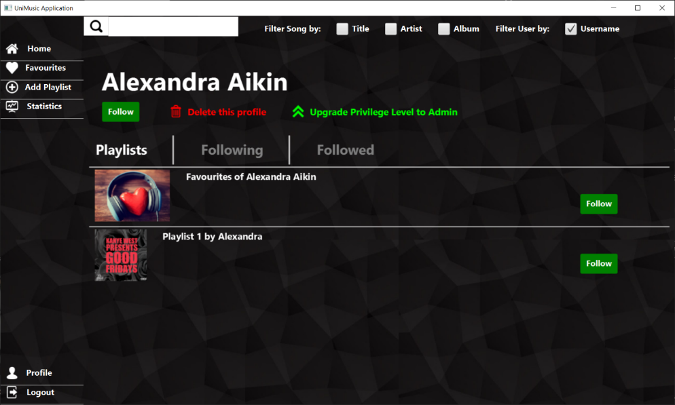

Pic. 10 User page for an Administrator